One click Report analysis
One-Click Report Analysis

1. Overview
When users submit a One-Click Report, the details of the report—including user actions—are captured and stored in the Salesforce Vlocity Error Log. This log serves as the primary source for analyzing issues encountered during the One-Click process. Screenshots of the error logs are referenced for additional clarity and validation. We focus more on screen frozen or screen struck issues reported by Agents.
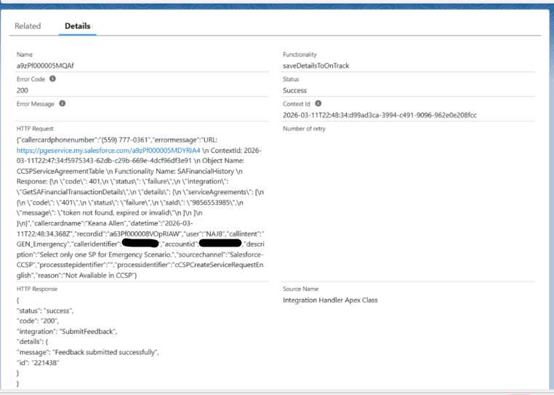

2. Identification of the Related OmniScript
To determine which OmniScript a One-Click Report is associated with, we analyze the ProcessIdentifier field in the Vlocity Error Log.
This identifier typically contains the name of the OmniScript that triggered the report, enabling us to precisely map the reported issue to the corresponding business flow.
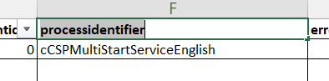

3. Error Analysis Using Vlocity Logs
Based on the timeframe of the issue and the agent LAN ID, we review the Vlocity Error Logs to identify relevant failures or exceptions. This step helps narrow down the exact execution window and user context in which the issue occurred.
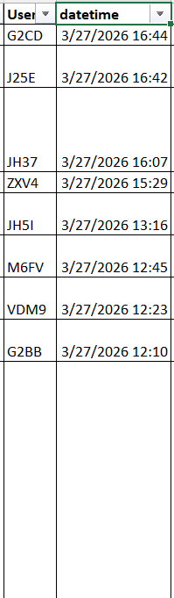

4. Direct Issue Investigation via Logged IDs
In some cases, the Vlocity Error Log or Exception Log ID is already captured within the Error Message column of the One-Click Report.
When this information is available, we can directly search for the corresponding record in Salesforce using the ID, significantly reducing the time required to identify and troubleshoot the issue.
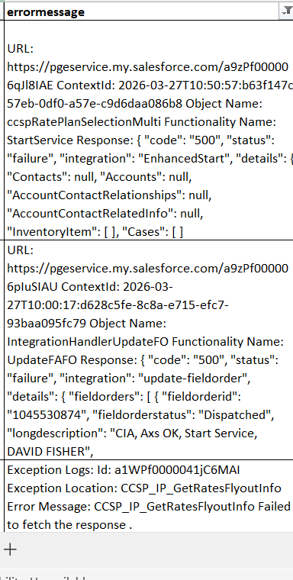

5. Exception and Error Log Examples

5.1 PS Exception Log
An example of a PS Exception Log is provided for reference, illustrating how system-level exceptions are captured during runtime.
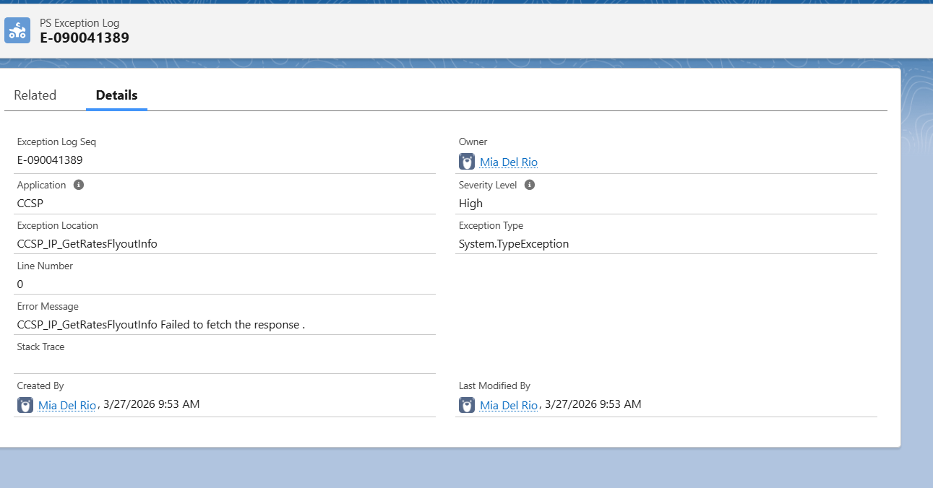

5.2 Vlocity Error Log
A sample Vlocity Error Log demonstrates how both the request and response payloads are recorded for a specific functionality. These details are critical for deeper root-cause analysis.
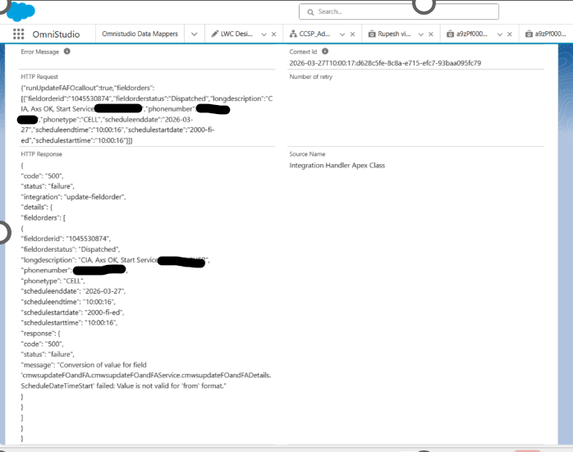

6. Challenges in Root Cause Identification
In approximately 80% of cases, the description provided in the One-Click Report is insufficient to determine the exact step where the user encountered an error.
In such scenarios, it becomes necessary to review the user interaction recording to accurately identify the failing step within the OmniScript flow.
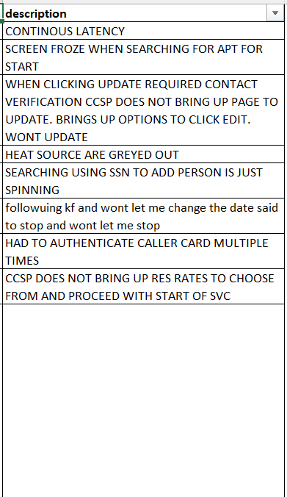

7. Reference Materials
For additional context, a sample One-Click Report Excel sheet (as exported from OneTrack) has been provided. This reference illustrates the structure and data fields available in the exported report.
27thMarch.xlsx

